As a devops engineer, we will have to take care of installation and debugging of the CRD/CR

Popular Custom Controllers: <https://www.cncf.io/>

Kubernetes sample controller: <https://github.com/kubernetes/sample-controller>

Istio: <https://github.com/istio/istio>

To install Istio:

* Install choco
* Install helm

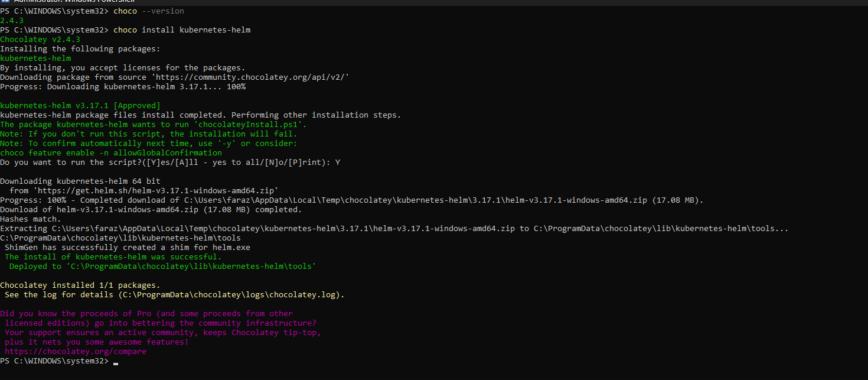

Now follow: <https://istio.io/latest/docs/setup/install/helm/>

